**Ideation Phase**

**Define the Problem Statements**

|  |  |
| --- | --- |
| Date | 30 June 2025 |
| Team ID | LTVIP2025TMID35420 |
| Project Name | Revolutionizing Liver Care : Predicting Liver Cirrhosis Using Advanced Machine Learning Techniques |
| Maximum Marks | 2 Marks |

**Customer Problem Statement:**

Liver cirrhosis is a silent and life-threatening disease that often remains undiagnosed until advanced stages. Traditional screening methods are costly, invasive, and inaccessible in rural and resource-limited settings. There is a lack of tools that can analyze routine health data to identify early signs of liver damage. Many patients and primary care doctors miss the opportunity for early diagnosis and treatment. This leads to increased healthcare costs, poor outcomes, and reduced quality of life.

* Early detection methods for liver cirrhosis are limited, especially in low-resource environments.
* Existing diagnostic tools are not patient-friendly, affordable, or easily scalable.
* Clinicians need AI-based support tools to predict cirrhosis using non-invasive, routine data.

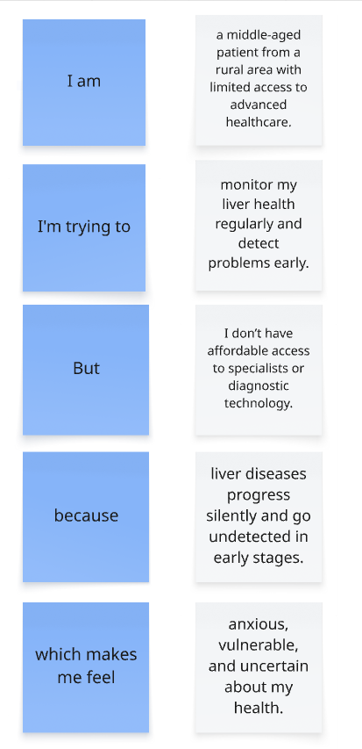

**Example:**

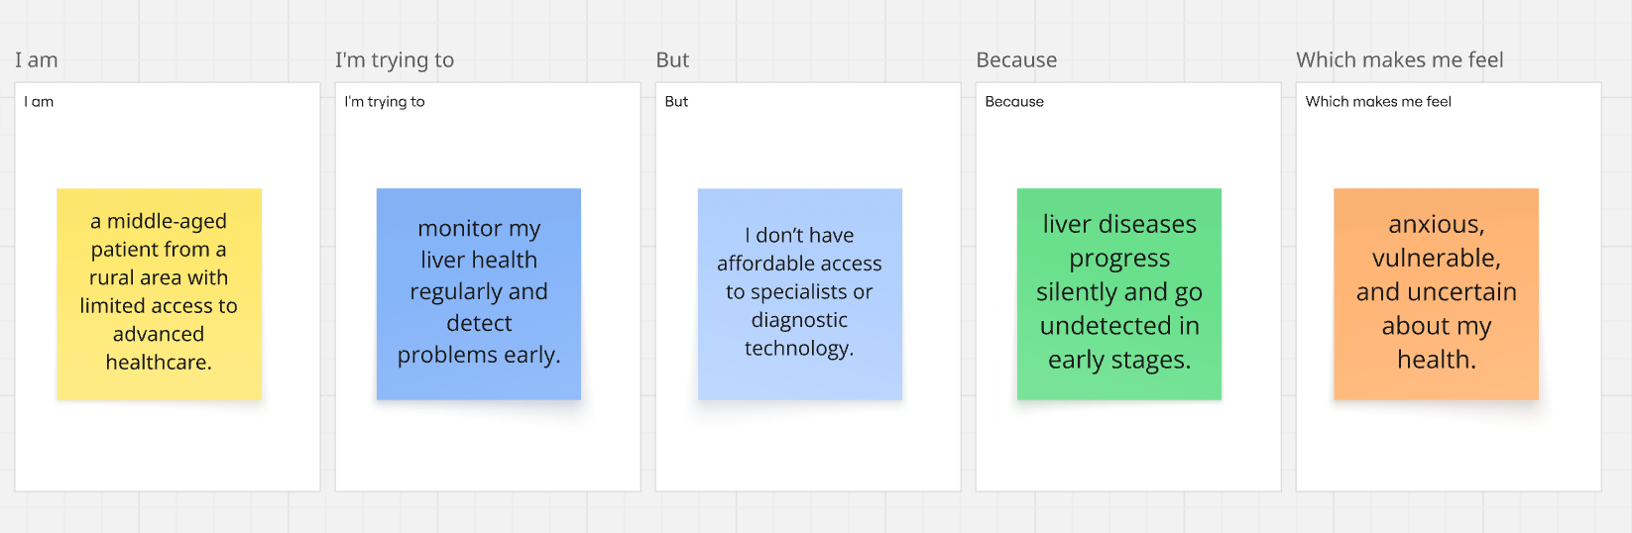

|  |  |  |  |  |  |
| --- | --- | --- | --- | --- | --- |
| **Problem Statement (PS)** | **I am (Customer)** | **I’m trying to** | **But** | **Because** | **Which makes me feel** |
| PS-1 | a middle-aged patient from a rural area with limited access to advanced healthcare. | monitor my liver health regularly and detect problems early. | I don’t have affordable access to specialists or diagnostic technology. | liver diseases progress silently and go undetected in early stages. | anxious, vulnerable, and uncertain about my health. |
| PS-2 | a general physician working in a community healthcare center. | identify liver cirrhosis risk early in patients using routine data. | I lack tools that help me predict the risk without invasive or expensive tests. | current methods require specialist interpretation and costly diagnostics. | ineffective and concerned about missing early signs in patients. |